**Kubernetes Architecture**

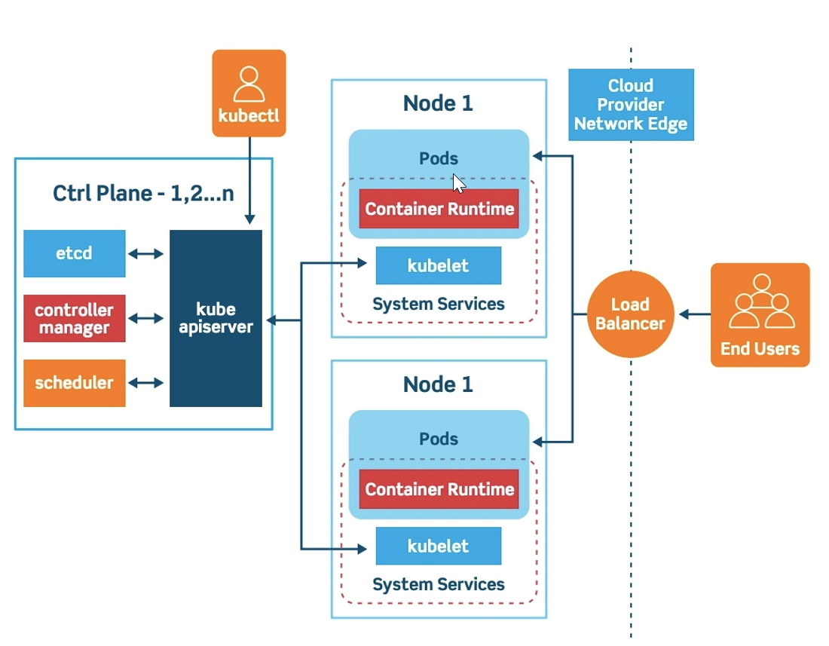

**ETCD:** ETCD is a distributed reliable key-value store that is simple, secure & fast.

Install ETCD:

1. Download Binaries by using curl command from github releases
2. Extract it by using tar xvzf ….
3. Run it by using ./etcd
4. It start services that listen on port 2379 by default.
5. The default client that comes with ETCD is ETCD control client.

Commands:

1.To store the key value: ./etcdctl set key1 value1

2.To retrieve the data: ./etcdctl get key1 o/p: value1

3.cat /etc/Kubernetes/manifests/kube-controller-manager.yaml

4.ps -aux | grep kube-scheduler

5. Yaml file example:

apiversion: v1

kind: pod

metadata:

name: nginx

labels:

app: nginx

tier: frontend

spec:

containers:

* name: nginx

image: nginx

* name: busybox

image: busybox

6. kubectl apply -f pod.yaml

7. Pod states: Pending, Running, Succeded, Failed, Unknown

8.